SNC Therapist Morning QA Procedure

**Purpose:** This procedure details the daily machine quality assurance performed by therapists on Elekta-1 and Elekta-2.

1. Load MOSAIQ SNC testing patient: **ZZZMORNING-1, WARMUP-ELEKTA-1** or **ZZZMORNING-2, WARMUP-ELEKTA-2**.
2. Open XVI at Elekta console. Click the MOSAIQ icon.
3. Prepare the linac.
   1. Log in to Service Mode using username and password service. (See Elekta Startup procedure.)
   2. Click the **Service Functions** (gear) icon.
   3. Click the **Deliver Quick Beam** icon.
4. In XVI, click **Display Service Pages**, **Default**, and **ASU**.
5. Do the following to set the gantry and then the collimator to 0°.
   1. Enter the value (0).
   2. Press Shift+< or Shift+> to move the gantry or collimator.
6. Log in to rightmost PC (if needed) using username onc1 and blank password.
7. Check the taskbar to see whether PDI Host is running. If it is not, double-click the PDI Host icon on the desktop.
8. Double-click SNC Routine icon on the desktop and log in with your email and password.
9. Navigate to the QA tasks.
   1. If daily QA has *not* been performed today on this machine, click the appropriate task under **Machine Tasks**.

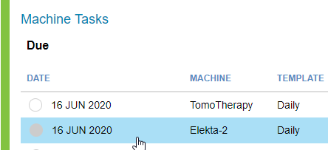

* 1. If daily QA *has* already been performed today on this machine, create a new QA task.
     1. Go to the **Dashboard**.



* + 1. Click **Run** under **Elekta-1** or **Elekta-2** menu.

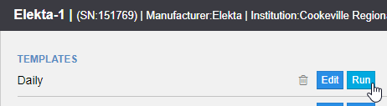

1. Click **Collect Background** if it appears in upper left corner. You should see a message that the background is valid.
2. Click **Activate QA Task** for the task you want to run.
3. If you are measuring electrons, insert the 20×20 cone into the linac. Insert the 20×20 square insert into the cone.
4. Set up SNC DQA3 detector.
   1. Take DQA3 from Engineers Room and set on couch top.
   2. Level DQA3 using a level. (There is a level in the physics cabinet.)
   3. Align DQA3 top center using X and Y lasers and dots seen on detector top.
   4. Raise couch top to set top of DQA3 measuring panel to 100 SSD (align to Z laser). If dust can be seen on top of detector, then detector is aligned. Alternatively, align to the Z laser using the front pointer.
   5. Fine tune X and Y alignments as in (c).
   6. Ensure that C light on side of detector is flashing.
5. In MOSAIQ, go to **RO Treat** > **QA Mode**. **Click Yes**.
6. Load beam to be tested.
7. In SNC, click **Start Measurement** for the task you want to run.
8. In MOSAIQ, shoot the beam.
9. If you need to rerun the test, click **Redo Measurement**.
10. To go to next SNC task, click **Advance**.
11. Repeat steps (13)–(17) for the remaining SNC tasks.
12. When finished, click **Complete** in upper right corner of SNC screen.
13. Review data results. If something did not pass, inform a physicist according to procedure.
14. Close SNC Routine.
15. Close PDI Host by right-clicking PDI icon in taskbar and selecting Exit.
16. Log off of MOSAIQ if you no longer need to use it.